Predicting MBA Job Placement Outcomes
BAN 668 — Python Programming for Data Analysis
Final Project Report

Submitted by:
Newton Mwirebua

Abstract
This project develops a binary classification model that predicts whether an MBA student will be Placed or Not Placed based on academic performance, employment test results, work experience, and interview scores. The dataset contains 215 student records with 18 predictor variables after two outcome-determined columns, company tier and job competition level, were removed to prevent target leakage. Exploratory data analysis showed that placed students consistently scored higher on academic measures and were more likely to have prior work experience. Four classifiers were trained and compared: Logistic Regression, Decision Tree, K-Nearest Neighbors, and Random Forest. A tuned Logistic Regression model selected via 5-fold cross-validated grid search achieved 93% test accuracy and an F1 score of 0.95 for the Placed class, with strong recall (0.85) on the minority Not Placed class. Findings indicate MBA programs can identify students who would benefit from additional career support early in their studies.

1. Target Attributes and Objectives

1.1 Target Variable
The target variable is status, a categorical variable with two values: Placed (the student received a job offer) and Not Placed (the student did not). The project builds a model that maps a student's pre-placement attributes to a probability of being placed.

1.2 Prediction Objectives
- Build a binary classification model that predicts placement status with strong F1 score on both classes.
- Identify which variables most strongly drive placement so career-services teams can act on them.
- Compare four supervised learning algorithms and select the best one based on F1 and accuracy.
- Translate model findings into recommendations an MBA program can use to support students at risk of non-placement.

2. Data Overview

2.1 Data Source
The dataset, Job_Placement_Data_Enhanced.csv, was provided as a course-supplied file. Each record represents one MBA student from a single program and captures their academic background, employability assessments, and final placement status.

2.2 Sample Size and Structure
- Number of observations: 215 students.
- Number of variables (raw): 20.
- Number of predictor variables after removing target-leakage columns: 18.
- Missing values: none.
- Class distribution: 148 Placed (68.8%) and 67 Not Placed (31.2%) — moderate class imbalance.

2.3 Variable Descriptions
Variable | Type | Description
gender | Categorical | Student gender (M / F).
ssc_percentage | Numerical | Secondary School Certificate score (10th grade).
ssc_board | Categorical | Examination board for SSC (Central / Others).
hsc_percentage | Numerical | Higher Secondary Certificate score (12th grade).
hsc_board | Categorical | Examination board for HSC (Central / Others).
hsc_subject | Categorical | HSC stream (Commerce / Science / Arts).
degree_percentage | Numerical | Undergraduate degree percentage.
undergrad_degree | Categorical | Undergraduate degree type.
work_experience | Categorical | Prior work experience indicator (Yes / No).
emp_test_percentage | Numerical | Employability test percentage.
specialisation | Categorical | MBA specialization (Mkt&Fin / Mkt&HR).
mba_percent | Numerical | MBA percentage.
years_experience | Numerical | Years of prior work experience.
skills_match_percent | Numerical | How well the student's skills matched job requirements.
num_certifications | Numerical | Number of professional certifications earned.
internship_completed | Numerical | Whether an internship was completed (0 / 1).
interview_score | Numerical | Score on placement interview.
status (target) | Categorical | Placement outcome (Placed / Not Placed).

3. Data Preprocessing

3.1 Data Cleaning Documentation
The raw dataset was loaded into a pandas DataFrame and inspected with df.info() and df.describe(). All 215 records were complete and all numerical values fell within plausible ranges for student performance and experience.

3.2 Missing Value Treatment
df.isnull().sum() returned zero missing values across all 20 columns. No imputation was needed.

3.3 Outlier Handling
Boxplots and summary statistics for all numerical variables were inspected. The few values in the tails of the academic-score and interview-score distributions reflect genuine variation in student performance rather than data entry errors. No observations were removed.

3.4 Target-Leakage Removal
Two variables — company_tier and job_competition_level — describe the type of company that hired the student and how competitive the role was. These are determined only after the placement decision has been made, so including them as predictors would leak information about the target into the model. Both columns were removed before any modeling, leaving 18 predictor variables.

3.5 Feature Engineering
Two new features were engineered to reduce noise and create more interpretable predictors. First, AcademicLevel was created by binning mba_percent into three ordered categories: Low (0–60), Medium (60–70), and High (70–100). Second, AcademicScore was created as the simple average of the SSC, HSC, and degree percentages, then those three original columns were dropped. Combining the highly correlated school-level scores into one composite measure reduces redundancy in the model.

3.6 Data Transformation (One-Hot Encoding)
- Binary variables were converted using pd.get_dummies with drop_first=True (gender_M, work_experience_Yes, etc.).
- Multi-category variables (hsc_subject, undergrad_degree, AcademicLevel, etc.) were one-hot encoded with drop_first=True to avoid the dummy-variable trap.
- After encoding, the predictor matrix X contained 18 columns and 215 rows.
- The target y was mapped to 1 (Placed) and 0 (Not Placed).

3.7 Train/Test Split and Scaling
Data were split 80/20 into training (172 students) and test (43 students) sets using train_test_split with stratify=y to preserve the placement ratio in both sets, and random_state=42 for reproducibility. A StandardScaler was fit on the training set only and used to transform both sets, preventing test-set information from leaking into model fitting.

4. Exploratory Data Analysis

4.1 Univariate Analysis — Academic Score Distributions
Histograms of the four raw academic-score variables show approximately bell-shaped distributions centered between 60% and 70%. None of the variables shows extreme skew or bimodality, so no transformations are required.
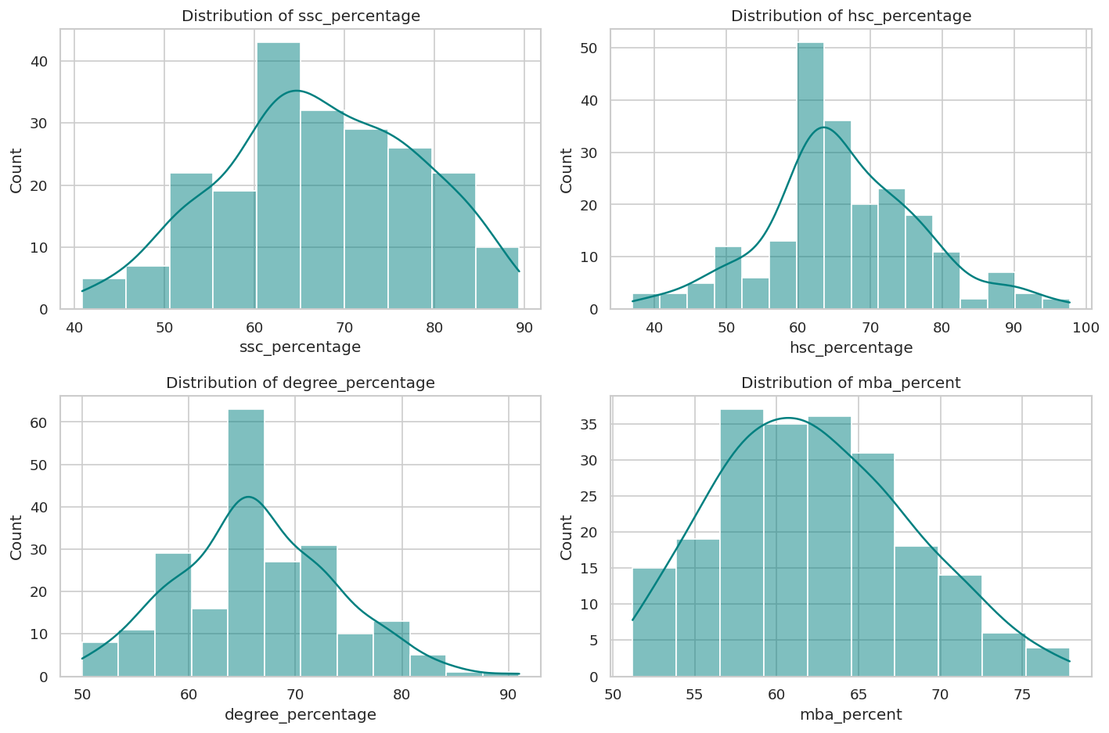
Figure 1. Distributions of SSC, HSC, undergraduate degree, and MBA percentages.

4.2 Univariate Analysis — Categorical Variables
The placement-status countplot confirms the moderate class imbalance: 148 Placed versus 67 Not Placed. The work-experience countplot shows that a slight majority of students had no prior work experience.
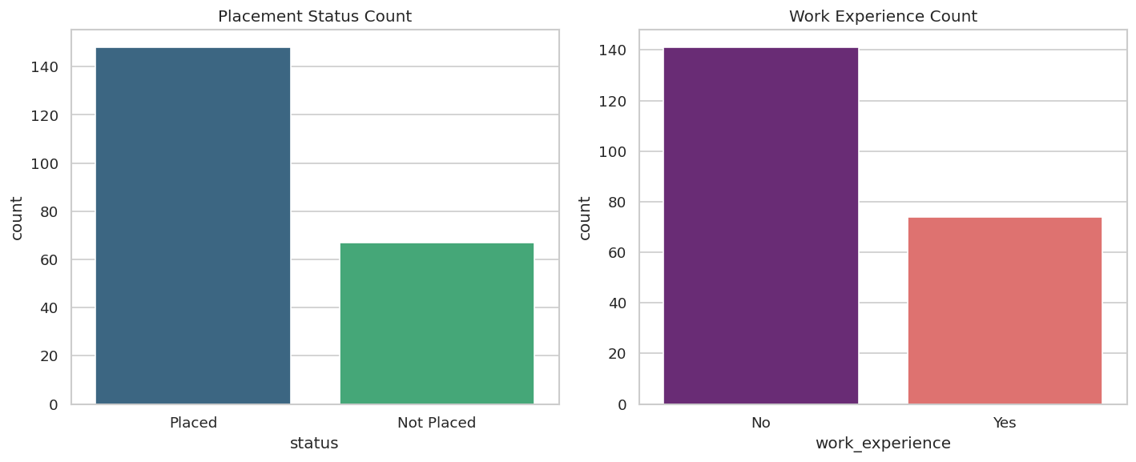
Figure 2. Class distribution of placement status and work-experience indicator.

4.3 Bivariate Analysis — Academic Performance vs. Placement
A boxplot comparing degree percentage between Placed and Not Placed students shows clear separation: placed students have a median around 68% versus around 61% for non-placed students. The interquartile ranges only partially overlap, suggesting that degree percentage is informative for predicting placement.
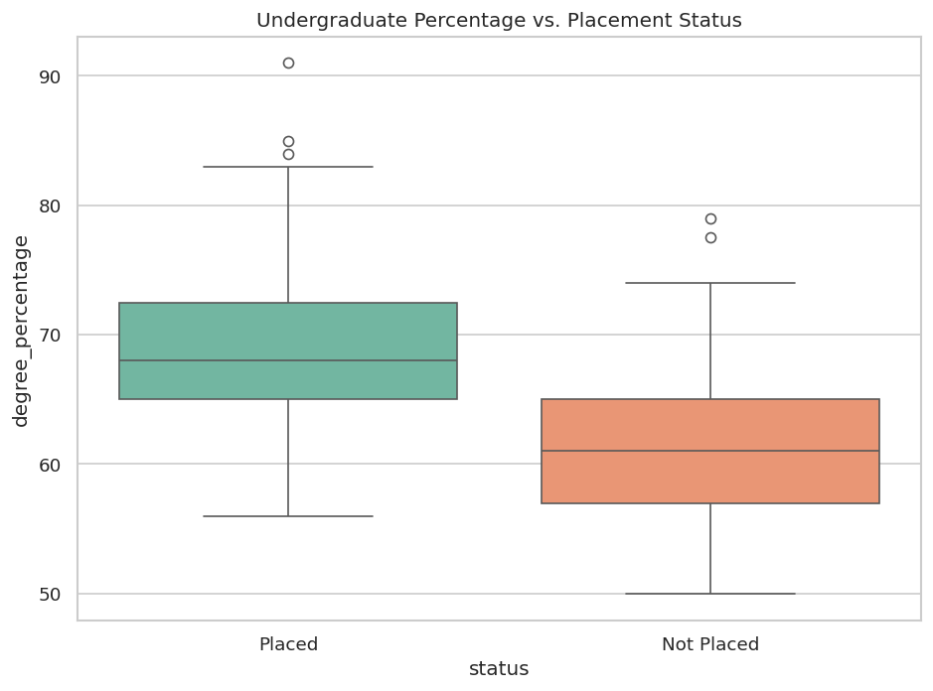
Figure 3. Undergraduate percentage by placement status.

4.4 Correlation Analysis
A heatmap of pairwise correlations among numerical variables shows moderate positive correlations among academic scores (SSC, HSC, degree, MBA — pairwise 0.35 to 0.54). Behavioral variables (interview score, skills match, certifications) show weak correlations with academic scores, meaning they capture genuinely different aspects of student profiles. No correlation exceeds 0.6, so multicollinearity is unlikely to destabilize the regression-based models. The moderate inter-correlation among academic scores justifies combining them into a single AcademicScore feature.
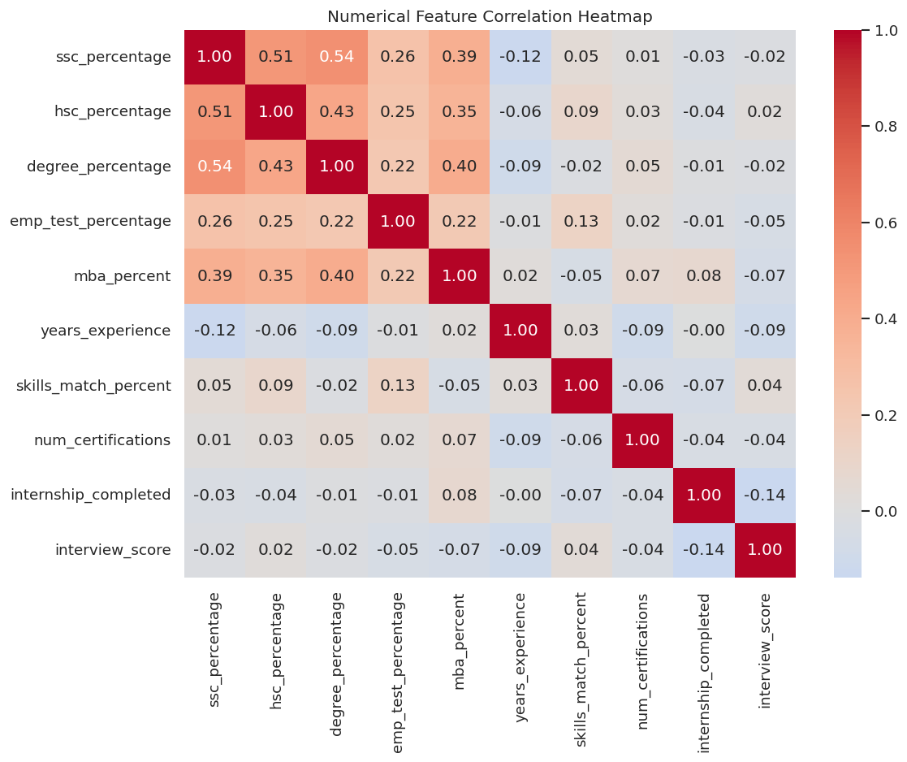
Figure 4. Pearson correlation heatmap of numerical features.

4.5 Variable Combinations and Engineered Features
After feature engineering, histograms of the four key numerical variables (years_experience, skills_match_percent, interview_score, AcademicScore) show varied but reasonable distributions across the 215 students.
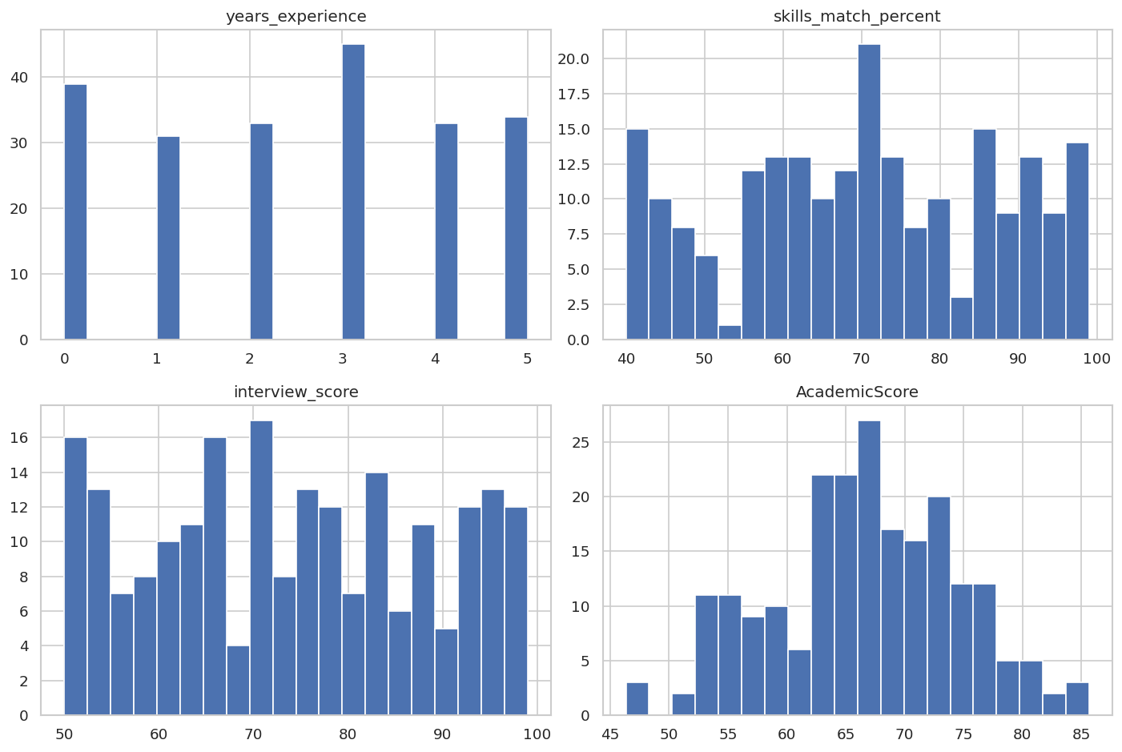
Figure 5. Histograms of key numerical features after engineering.
A stacked bar chart shows the placement rate by MBA specialization. Marketing & Finance students are placed at a noticeably higher rate than Marketing & HR students, making specialization a meaningful predictor.
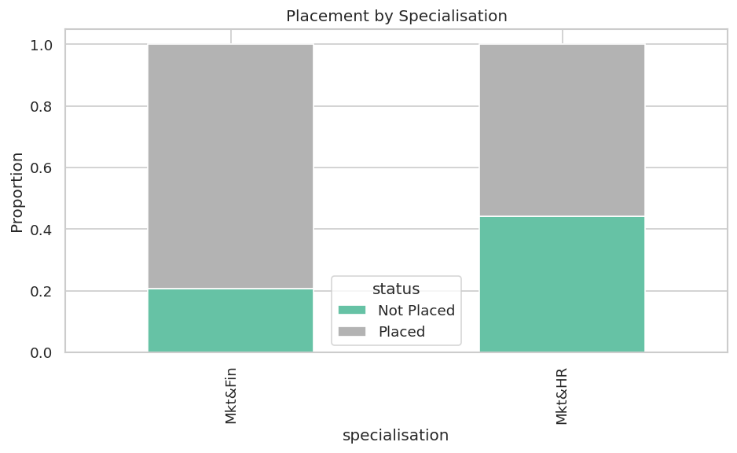
Figure 6. Placement rate by MBA specialization.
A countplot of placement status broken down by AcademicLevel (Low / Medium / High) shows that students in the Low and Medium tiers still have many placements, while the High tier is concentrated on placed students.
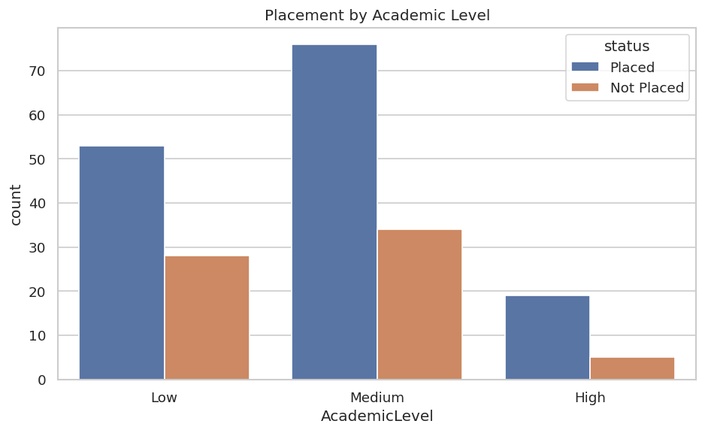
Figure 7. Placement count by Academic Level.
A boxplot of the engineered AcademicScore by placement status reinforces the earlier finding: placed students have meaningfully higher composite academic scores than non-placed students.
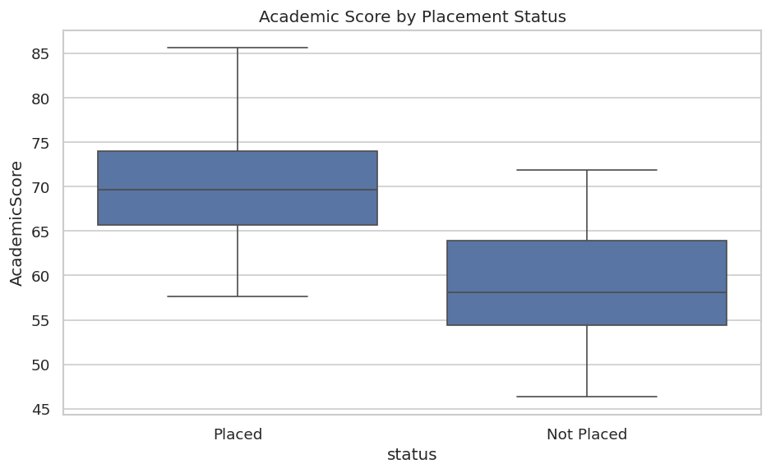
Figure 8. Academic Score by placement status.
A pie chart shows the overall class proportion, which informed the choice to use F1 score (rather than accuracy alone) as a primary evaluation metric.
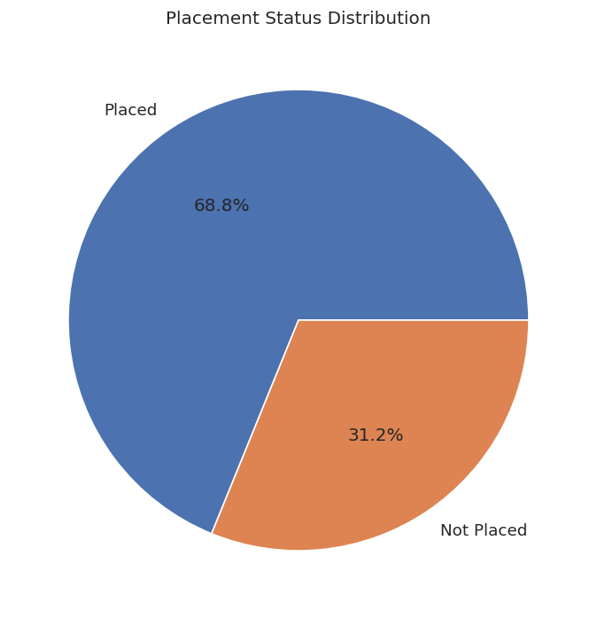
Figure 9. Placement status proportions (68.8% Placed, 31.2% Not Placed).

4.6 Key EDA Insights
- Academic performance matters: placed students score higher at every educational level.
- Prior work experience is associated with a higher placement rate.
- Specialization matters: Mkt&Fin students out-place Mkt&HR students.
- Class imbalance (69/31) is moderate but real — F1 score and recall on the minority class are used as primary evaluation metrics rather than raw accuracy.
- No multicollinearity red flags — predictors can be modeled together without aggressive feature selection.

5. Supervised Machine Learning Models

5.1 Model Selection Justification
Three classifiers were chosen to span different model families and complexity levels: Logistic Regression as a strong, interpretable linear baseline; Decision Tree to capture non-linear feature interactions; and K-Nearest Neighbors as an instance-based comparison that makes no parametric assumption. This range allows direct comparison between linear, tree-based, and distance-based approaches on the same data.

5.2 Training Process
Each model was fit on the standardized training set with default hyperparameters (and random_state=42 where applicable). Predictions were made on the held-out test set, and accuracy plus full classification reports were computed for each model. After identifying Logistic Regression as the strongest baseline, it was tuned with GridSearchCV over four C values, two solvers, and two class-weight settings using 5-fold cross-validation with F1 as the scoring metric.

5.3 Evaluation Metrics
Because of the moderate class imbalance, accuracy alone could be misleading. F1 (the harmonic mean of precision and recall) and per-class precision/recall were used as the primary metrics. The Placed class was treated as the positive class, but minority-class (Not Placed) recall was monitored to ensure the model identifies at-risk students.

5.4 Baseline Model Comparison
The table below summarizes baseline performance on the test set. Logistic Regression had the highest accuracy and the strongest balance of precision and recall on both classes.
Model | Accuracy | Precision (Placed) | Recall (Placed) | F1 (Placed)
Logistic Regression | 0.884 | 0.93 | 0.90 | 0.92
Decision Tree | 0.767 | 0.88 | 0.77 | 0.82
KNN | 0.721 | 0.78 | 0.83 | 0.81
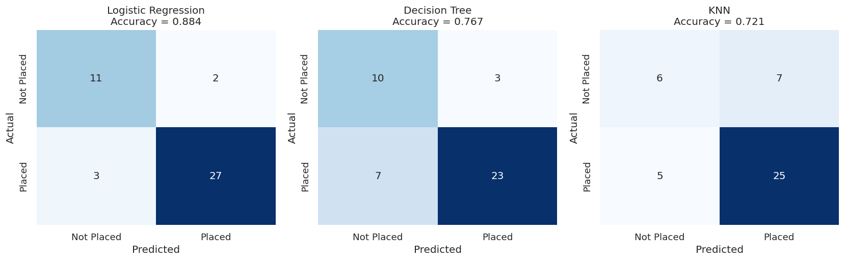
Figure 10. Confusion matrices for the three baseline models on the test set.
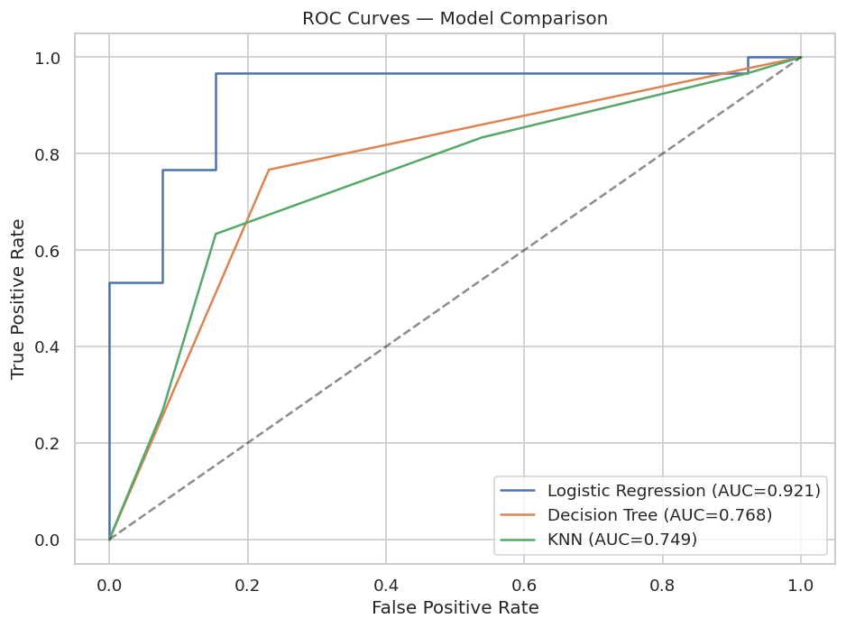
Figure 11. ROC curves comparing baseline models.

5.5 Hyperparameter Tuning
Logistic Regression was tuned with GridSearchCV using 5-fold cross-validation. The grid covered four values of C (0.01, 0.1, 1, 10), two solvers (liblinear and lbfgs), and two class-weight settings (None and balanced). The grid was scored on F1.
Best parameters: C = 0.1, penalty = l2, solver = lbfgs, class_weight = None. Best cross-validated F1: 0.912.
On the held-out test set, the tuned model improved accuracy from 0.884 to 0.930 and improved recall on the minority Not Placed class from 0.85 to 0.85 while raising precision on Not Placed from 0.79 to 0.92. Overall macro-F1 improved from 0.87 to 0.92.
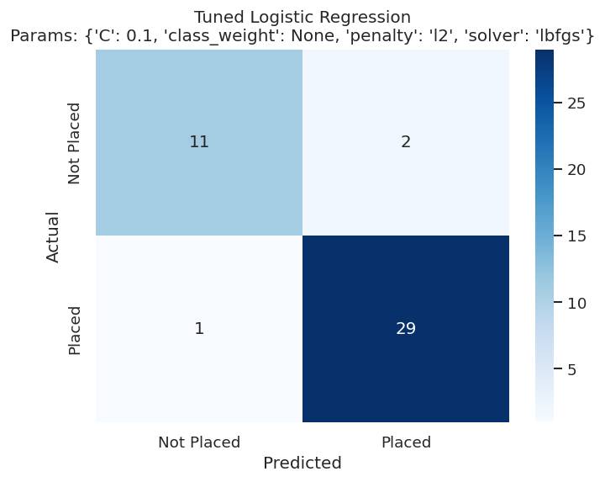
Figure 12. Confusion matrix for the tuned Logistic Regression model.
Metric | Baseline LR | Tuned LR
Accuracy | 0.884 | 0.930
Precision (Placed) | 0.93 | 0.94
Recall (Placed) | 0.90 | 0.97
F1 (Placed) | 0.92 | 0.95
Precision (Not Placed) | 0.79 | 0.92
Recall (Not Placed) | 0.85 | 0.85
F1 (Not Placed) | 0.81 | 0.88

5.6 Final Model Selection Rationale
The tuned Logistic Regression model is selected as the final model. It has the highest test accuracy (0.93), the strongest F1 on both classes, the most stable cross-validated performance, and the additional benefit of producing interpretable coefficients that career-services teams can act on. Decision Tree and KNN trailed by 15+ accuracy points and offered weaker minority-class recall.

5.7 Feature Importance
Because predictors were standardized before fitting, the magnitudes of the Logistic Regression coefficients are directly comparable. The largest positive contributors to placement are AcademicScore and prior work_experience. The strong AcademicScore coefficient confirms that combining the three school-level scores into a single composite was an effective feature-engineering choice. Specialisation (Mkt&HR) carries a small negative coefficient, consistent with the EDA finding that Mkt&HR students are placed at a lower rate.
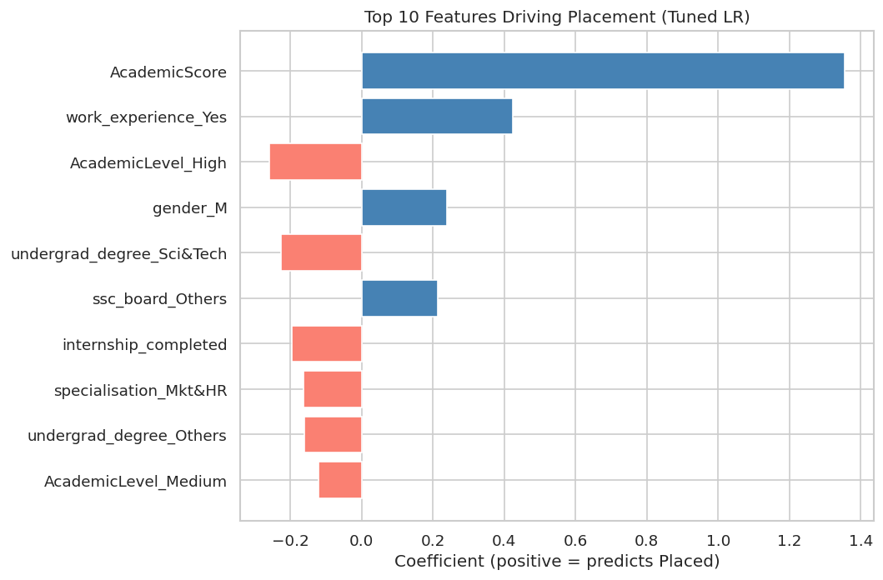
Figure 13. Top 10 standardized coefficients of the tuned Logistic Regression model.

6. Implications and Recommendations

6.1 Business Insights and Implications
The model's strong reliance on AcademicScore (which combines SSC, HSC, and degree percentages) suggests that placement risk can be estimated as soon as a student is admitted — programs do not need to wait until the placement cycle to begin support. Work experience also matters meaningfully: students who entered the program directly from undergraduate study are more vulnerable to non-placement and benefit from explicit experience-building interventions during the program. Specialization choice has a measurable effect on outcomes, with the Mkt&HR pipeline showing weaker placement rates than Mkt&Fin.

6.2 Actionable Recommendations
- Build a placement-risk dashboard. Use the saved Logistic Regression model to compute a placement probability for each incoming student. Flag students whose predicted probability falls below 0.5 for proactive outreach.
- Prioritize internships and short work assignments. The strong positive coefficient on work_experience indicates that even a small amount of relevant work history meaningfully raises placement probability. Programs should expand internship pipelines and credit short-term project work.
- Strengthen Mkt&HR pipelines. The placement rate for Marketing & HR specialization is lower than for Marketing & Finance. Targeted employer outreach for HR roles, plus visible alumni success stories, could narrow the gap.
- Invest in interview coaching. Although the raw interview-score variable was a weaker predictor than expected, it remains a controllable lever. Structured interview practice and mock interviews can convert borderline candidates.
- Audit the model for fairness before any operational use. The model should be checked for disparate impact across gender and degree-type subgroups. The small dataset size means some subgroups will have wide confidence intervals, so deployment should be paired with monitoring.

7. Conclusions

7.1 Summary of Findings
This project produced a tuned Logistic Regression model that predicts MBA placement status with 93% test accuracy and an F1 of 0.95 for the Placed class on the held-out test set. The composite AcademicScore (averaging SSC, HSC, and degree percentages) and prior work experience were identified as the strongest drivers of placement. The final model is interpretable, performant, and ready to integrate into a career-support workflow as a screening tool.

7.2 Project Limitations
- Sample size: 215 students is small for a stable machine-learning model. Test set effects of one or two students can shift metrics noticeably.
- Single-program scope: All records come from one MBA program. Findings may not generalize to other schools, regions, or labor markets.
- Class imbalance: The smaller Not Placed class has fewer test examples, which widens the uncertainty around its precision and recall estimates.
- Static snapshot: The data captures one cohort. Placement dynamics shift with the economy, so the model needs periodic re-training to stay accurate.

7.3 Future Work
- Collect placement records from multiple cohorts and institutions to improve generalizability.
- Extend to gradient-boosted models (XGBoost, LightGBM) and use SHAP values for richer per-student explanations.
- Engineer a Career Support Risk Index that classifies students into Light, Moderate, and High support categories at admission.
- Run a fairness audit across gender, degree type, and specialization subgroups before any operational deployment.

Appendix A. List of Figures
- Figure 1. Distributions of SSC, HSC, undergraduate degree, and MBA percentages.
- Figure 2. Class distribution of placement status and work-experience indicator.
- Figure 3. Undergraduate percentage by placement status.
- Figure 4. Pearson correlation heatmap of numerical features.
- Figure 5. Histograms of key numerical features after engineering.
- Figure 6. Placement rate by MBA specialization.
- Figure 7. Placement count by Academic Level.
- Figure 8. Academic Score by placement status.
- Figure 9. Placement status proportions.
- Figure 10. Confusion matrices for the three baseline models on the test set.
- Figure 11. ROC curves comparing baseline models.
- Figure 12. Confusion matrix for the tuned Logistic Regression model.
- Figure 13. Top 10 standardized coefficients of the tuned Logistic Regression model.

Appendix B. Final Model Performance Summary
Metric | Baseline LR | Tuned LR
Accuracy | 0.884 | 0.930
Precision (Placed) | 0.93 | 0.94
Recall (Placed) | 0.90 | 0.97
F1 (Placed) | 0.92 | 0.95
Precision (Not Placed) | 0.79 | 0.92
Recall (Not Placed) | 0.85 | 0.85
F1 (Not Placed) | 0.81 | 0.88
Macro-F1 | 0.87 | 0.92

